# E.G.C Year 12 2016

# Mathematical Methods Investigation 3

Out of Class Section

**NORMAL DARTBOARDS**

Name:

**DATE**: Handout: Monday July 25th 2016

Due: Monday August 1st 2016

Test day: Thursday August 4th 2016

* *The Out of Class Investigation is designed for you to learn the essentials needed for the In-Class validation.*
* *This is the “Take Home” part of the Investigation. It does not count towards your mark for this investigation.*

This investigation covers three main ideas:

* Continuous Probability Distributions
* The Normal distribution Curve

**Part One: Dartboards**

A game developer is experimenting with different dart board shapes. He is looking at certain dartboard designs and is considering the chance of hitting certain parts of the board. In each problem the area of certain sections can be calculated using calculus or by using geometrical shape rules.

Assume the dart always hits the board in these problems.

1. For each dartboard following you are required to calculate the following probabilities.

* P(x<1)
* P(2<x<4)
* P(x≥3/x<4)
* P(1<x<2 or x≥4)

To get you started an example has been given to you below.

|  |  |
| --- | --- |
| Example Dartboard | Sketch |
| =  =    OR use the formula for area of a triangle  Area = baseheight | =  =  =  OR use the formula for area of a trapezium  Area = sum of the parallel sidesperpendicular distance between them. |

|  |  |
| --- | --- |
| Dartboard 1 | Sketch |
|  |  |
|  |  |

|  |  |
| --- | --- |
| Dartboard 2 | Sketch |
|  |  |
|  |  |

|  |  |
| --- | --- |
| Dartboard 3 | Sketch |
|  |  |
|  |  |
| Dartboard 4 | Sketch |
|  |  |
|  |  |

|  |  |
| --- | --- |
| Dartboard 6 | Sketch |
|  |  |
|  |  |

|  |  |
| --- | --- |
| Dartboard 5    where (a constant)  *Remember:* The *e* symbol is on your virtual keyboard and you can do integrals on the calculator. | Sketch |
|  |  |
|  |  |

2 The game developer wishes to establish a gambling club so that the patrons can bet on a machine which throws a dart at random at a board. He decides that it would be easier for calculation purposes if the total area of each board was ***1 square unit***, thus ensuring that the integrals give probabilities directly.

(a) Which of the dartboards would satisfy this requirement? Justify your answers using calculus.

(b) He plans to design boards according to the following specifications. The boundaries of the board are the given function over the stated domain and the positive x axis. Calculate the value of k so that the total area of each board is 1 square unit.

1. y = k(5 – x) for -2 ≤ x ≤ 4
2. y = kx2(1 – x) for 0 < x < 1
3. y = kx 0 < x < 2
4. y = kx3 for 0 < x < 1
5. y =  for 0 < x < 4

**Part Two: The Normal Distribution**

**Analysing Heights**

The data given here is the heights (in centimetres) of a random group of high school students taken from Census on Line on the Australian Bureau of Statistics website on 6th June 2016.

**Boys:**

|  |  |  |  |  |  |  |  |  |  |  |
| --- | --- | --- | --- | --- | --- | --- | --- | --- | --- | --- |
| 183 | 175 | 186 | 185 | 188 | 174 | 175 | 181 | 183 | 180 | 185 |
| 160 | 184 | 179 | 185 | 174 | 180 | 194 | 172 | 176 | 171 | 175 |
| 178 | 172 | 165 | 175 | 187 | 189 | 182 | 180 | 182 | 178 |  |
| 179 | 173 | 181 | 190 | 180 | 175 | 186 | 175 | 162 | 192 |  |
| 171 | 187 | 174 | 186 | 180 | 185 | 178 | 195 | 165 | 183 |  |

**Girls:**

|  |  |  |  |  |  |  |  |  |  |
| --- | --- | --- | --- | --- | --- | --- | --- | --- | --- |
| 156 | 181 | 173 | 150 | 180 | 165 | 169 | 173 | 169 | 168 |
| 170 | 160 | 165 | 160 | 173 | 197 | 154 | 172 | 165 | 168 |
| 165 | 163 | 170 | 153 | 171 | 152 | 163 | 163 | 164 | 155 |
| 180 | 160 | 163 | 160 | 157 | 170 | 164 | 167 | 171 |  |
| 162 | 173 | 168 | 146 | 163 | 157 | 171 | 163 | 170 |  |

3. For each distribution use your calculator to determine the number, the mean and standard deviation.

|  |  |  |
| --- | --- | --- |
|  | Boys | Girls |
| Number |  |  |
| Mean height |  |  |
| Standard deviation |  |  |

4. Grouping the data in 5cm intervals, starting from 127.5cm to 132.5 cm, draw histograms for

each set of data.

|  |  |  |
| --- | --- | --- |
| Class interval | Frequency Boys | Frequency Girls |
| 142.5 – 147.5 |  |  |
| 147.5 – 152.5 |  |  |
| 152.5 – 157.5 |  |  |
| 157.5 – 162.5 |  |  |
| 162.5 – 167.5 |  |  |
| 167.5 – 172.5 |  |  |
| 172.5 – 177.5 |  |  |
| 177.5 – 182.5 |  |  |
| 182.5 – 187.5 |  |  |
| 187.5 – 192.5 |  |  |
| 192.5 – 197.5 |  |  |
| 197.5 – 202.5 |  |  |

Histograms:

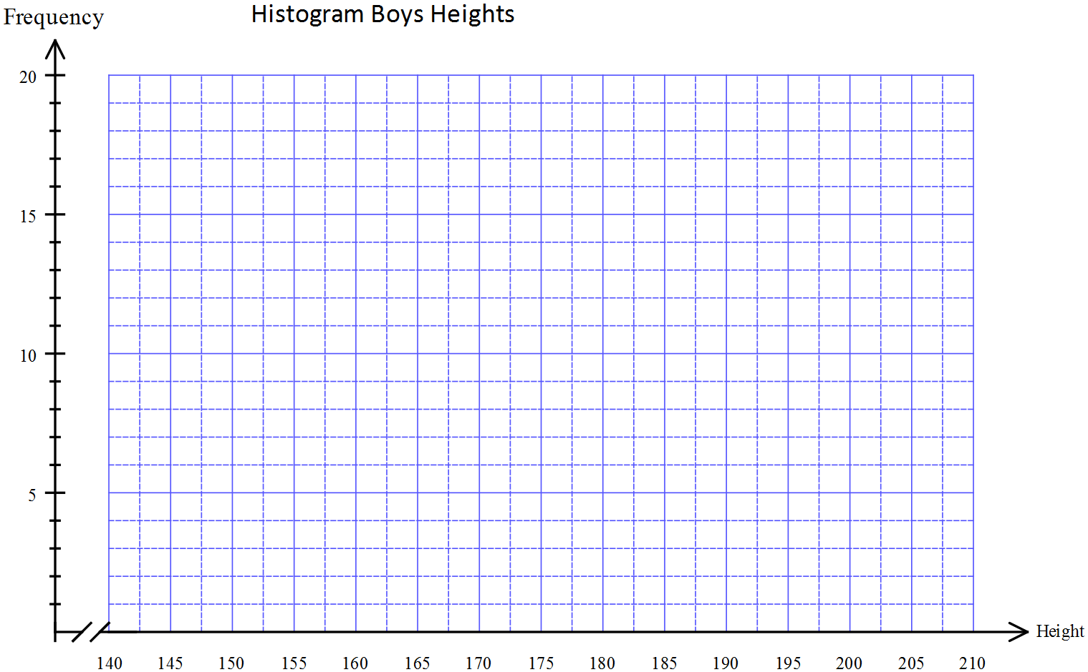

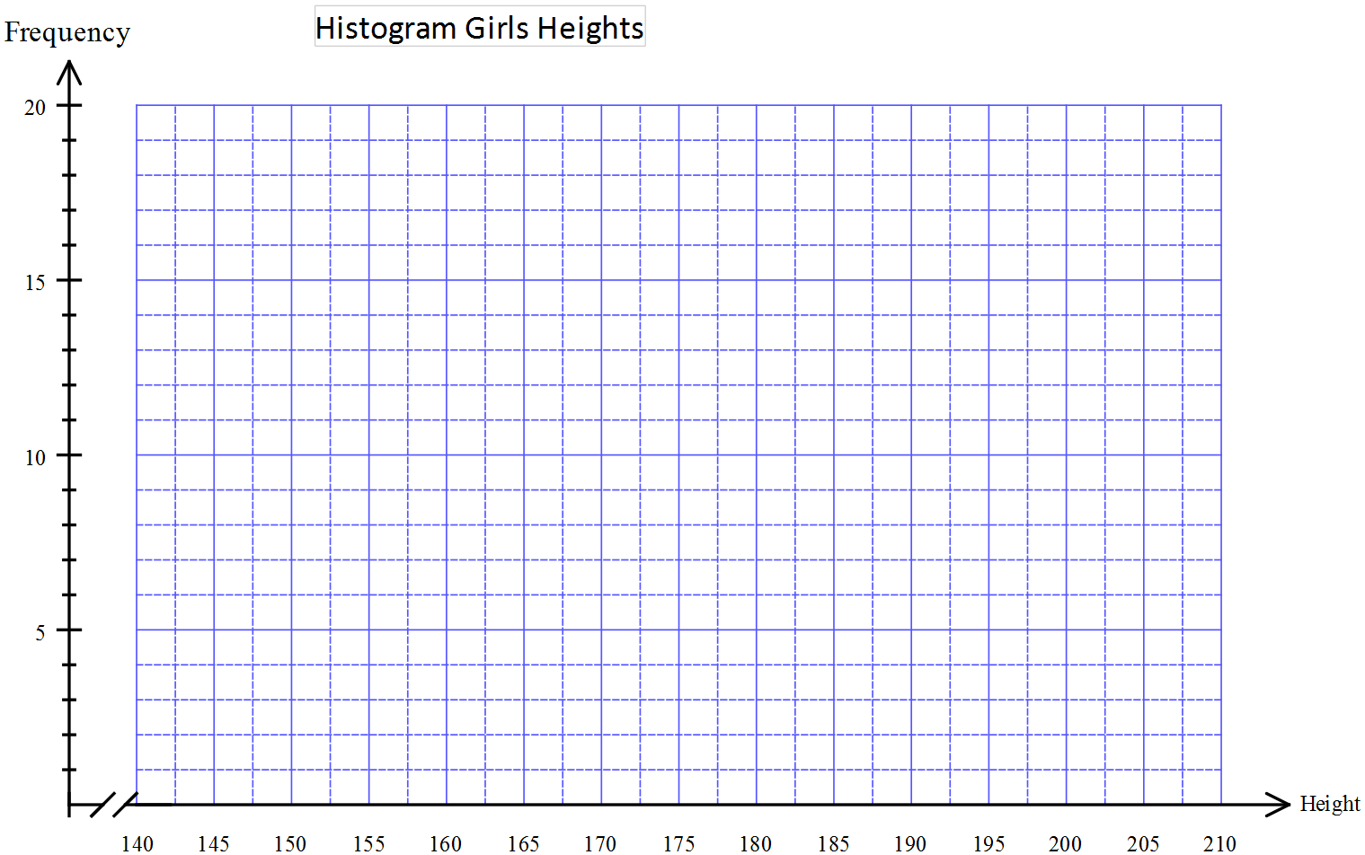

Comment on the shape of each histogram.

Both sets of data collected would be from normal distributions. A normal distribution has a symmetrical spread of data about the mean. The sketch here shows a standard normal distribution:



The values on the horizontal axis are standard deviations from the mean which is at zero.

As you can see from the sketch, a normal distribution spreads for about three standard deviations either side of the mean.

5. Comment on the shape of your two histograms in comparison with the shape of a normal

distribution. Do they seem to match a normal distribution? Explain your answer.

The “bell shaped” Normal curve is a

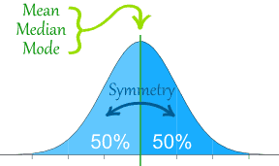very common distribution.

|  |  |
| --- | --- |
| The Normal Distribution has:   * [mean](http://www.mathsisfun.com/mean.html) = [median](http://www.mathsisfun.com/median.html) = [mode](http://www.mathsisfun.com/mode.html) * symmetry about the centre * http://www.mathsisfun.com/data/images/normal-distrubution-3sds.gif50% of values less than the mean  and 50% greater than the mean |  |
|  | 68% of values are within 1 standard deviation of the mean          95% are within 2 standard deviations          99.7% are within 3 standard deviations |

In a normal distribution 68% of the data should be within one standard deviation of the mean i.e. 

6. Find the interval of heights that is within one standard deviation of the mean for the two sets of

Data, boys and girls heights.

7. Calculate the percentage of heights within these intervals for the boys and girls data.

8. Comment on the values for the two data sets compared to the expected percentage.

In a normal distribution 95% of the data should be within two standard deviations of the mean i.e. 

9. Find the interval of heights that is within two standard deviations of the mean for the two sets

of data, boys and girls heights.

10. Calculate the percentage of heights within these intervals for the boys and girls data.

11. Comment on the values for the two data sets compared to the expected percentage.

In a normal distribution 99.7% of the data should be within three standard deviations of the mean i.e. 

12. Find the interval of heights that is within three standard deviations of the mean for the two

sets of data, boys and girls heights.

13. Calculate the percentage of heights within these intervals for the boys and girls data.

14. Comment on the values for the two data sets compared to the expected percentage.

The heights of one girl and one boy are measured to be; Suzie 173 cm and Michael 182 cm. Relative to their gender group it appears that these heights are similar.

15. Indicate on the histograms where these two heights are.

16. Show that Suzie’s height is 0.83 standard deviations above the mean relative to the girls’ data.

17. Calculate how many standard deviations more than the mean Michael’s height is. For this

calculation use the boys’ mean and standard deviation.

18. Relative to their gender group, who is the tallest? Explain your answer.

19. Do a similar comparison between Angie at 155 cm and Brad at 171 cm. Explain your result.

20. Is there any height which is more than 3 standard deviations away from either the boy’s or girl’s mean? Justify your answer

21. Your Casio can draw a sample from a Normal Distribution.

You must feed in the mean, standard deviation and number of sample points you need.

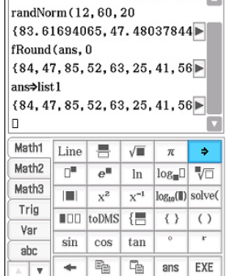Shown below is an example of a sample of 20 being drawn from a

Normal distribution with a mean of 60 and a standard deviation

of 12.

The sample points have been rounded and stored into List 1 on Statistics.

Your task: assuming Australian male heights are 176 cm and

the standard deviation 7 cm use your calculator to produce on your

calculator

* 200 sample points and store them into List 1.
* A histogram of these points starting from 150 cm going up in

steps of 5 cm. How closely does this match the Normal curve?

* Find what percentage of your sample points are greater than 2 standard deviations above the mean.
* Use Normal CDF to see how closely this result for your sample matches the theoretical Normal result.

